Advanced Web Apps

# Module 05

Module 05 Course Project – Forms 2



Rasmussen College - Professor Corey

This project involved the addition of a page designed to display a form which will allow the user to gain access to the site. First, the user must make a selection with the drop-down list tool, and then from there, the user must provide credentials to access the content. This is a helpful feature to improve security within the site and allow for the control of which content we want the viewer or user to see in a particular section of our site. The photos of my site are located below and show the index, about page, and also different screen resolutions with the help of the Chrome developer tools.

Github and Filezilla links: <https://github.com/jasonhkendall/AdvancedWebApps/tree/master/module05/project>

<https://sotd.us/jasonkendall/module05/project/index.html>

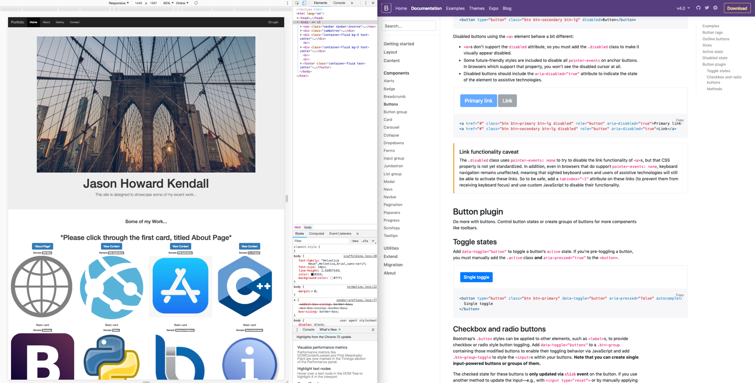

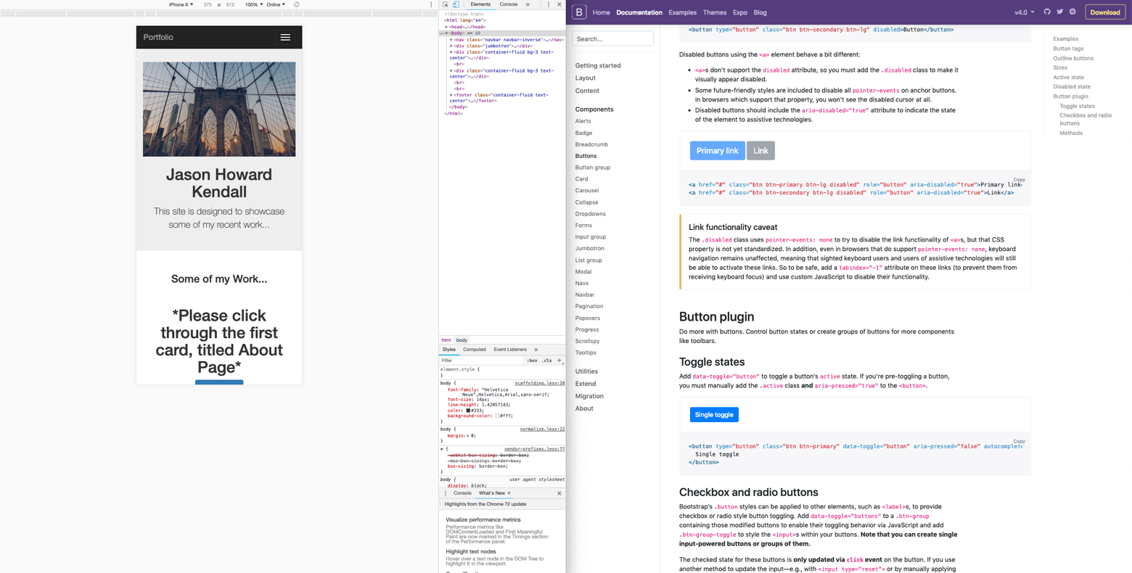

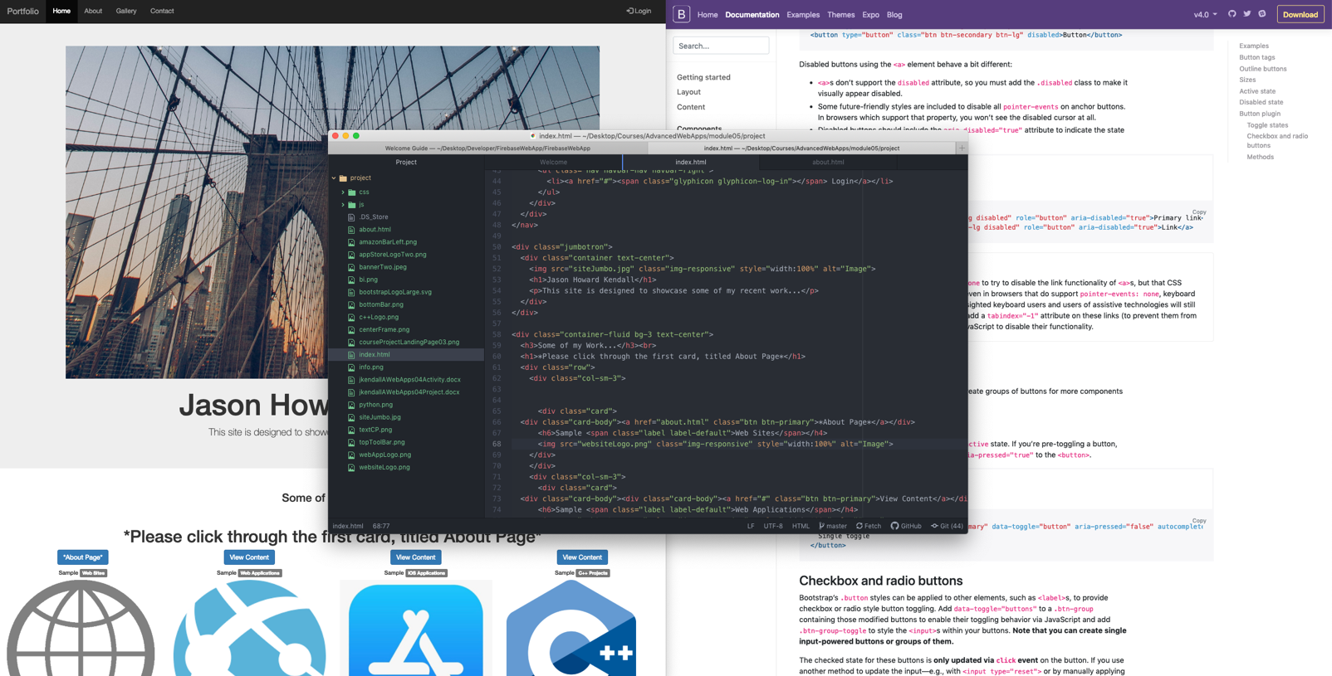

Thanks!